**NAME : Mirnalini S**

**Email : mirnajana2000@gmail.com**

**Batch :** RSIP Career Basic ML 066

**Internship :** smartinternz.com (TheSmartBridge Internships)

**organizer**

**MACHINE LEARNING BASED INTERNSHIP PROJECT REPORT.**



**Resale value preditcion**

**Using**

**Watson Auto AI**

**INDEX**

**INTRODUCTION**

**a. Overview**

**b. Purpose**

**LITERATURE SURVEY**

**a. Existing problem**

**b. Proposed solution**

**THEORETICAL ANALYSIS**

**a. Block diagram**

**b. Hardware / Software designing**

**EXPERIMENTAL INVESTIGATION**

**FLOW CHART**

**RESULT**

**ADVANTAGES & DISADVANTAGES**

**APPLICATION**

**CONCLUSION**

**FUTURE SCOPE**

**BIBLIOGRAPHY**

**INTRODUCTION**

**Overview**

The Project "Resale value prediction using Watson Auto AI" is to be able to predict the salvage value (residual value) of cars with accuracy.

The project is based on IBM provided features. It consist of Watson studio Auto AI experment whic uses different pipelines and uses the best one.The prediction is shown using Node Red app dashboard.

The main factors are the time in which vehicle got registered, number of kms it drove, power, type of gear box, model of the car, any damage or repair, fuel type etc. Considering the main factors which would affect the resale value of a vehicle a regression model is to be built that would give the nearest resale value of the vehicle.

**PURPOSE**

**LITERATURE SURVEY**

Accurate car price prediction involves expert knowledge,because price usually depends on many distinctive features and factors. Typically, most significant ones are brand and model, age, horsepower and mileage. The fuel type used in the car as well as fuel consumption per mile highly affect price of a car due to a frequent changes in the price of a fuel. Different features like exterior color, door number, type of transmission, dimensions, safety, air condition, interior, whether it has navigation or not will also influence the car price. In this paper, we applied different methods and techniques in order to achieve higher precision of the used car price prediction.Thus, it is of commercial interest to seller/financers to be able to predict the salvage value (residual value) of cars with accuracy.

**Existing problem**

With difficult economic conditions, it is likely that sales of second-hand imported (reconditioned) cars and used cars will increase. In many developed countries, it is common to lease a car rather than buying it outright. A lease is a binding contract between a buyer and a seller (or a third party – usually a bank, insurance firm or other financial institutions) in which buyer must pay fixed instalments for a pre-defined number of months/years to the seller/financer. After the lease period is over, the buyer has the possibility to buy the car at its residual value, i.e. its expected resale value.

**Propesed Solution**

if we use machine learning then we can predict the resale value of a vehicle by regression model is to be built that would give the nearest resale value of the vehicle.

**THEORETICAL ANALYSIS**

**Block Diagram**

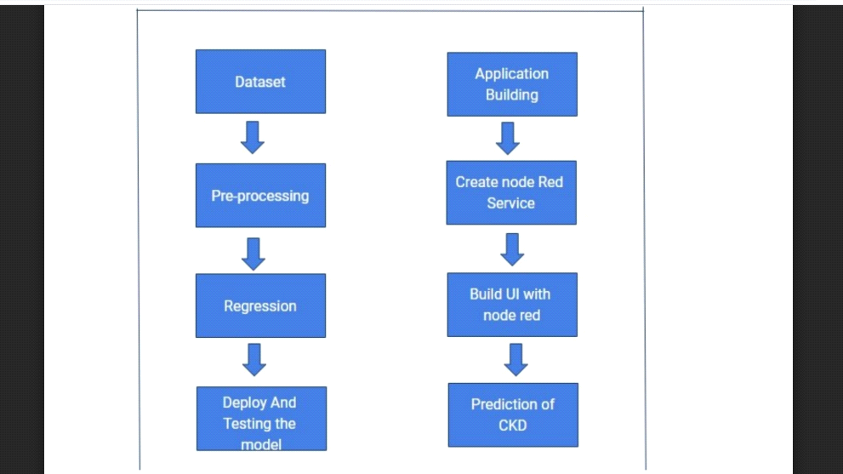

In Machine Learning according to these steps machinecan predict the result also one more benefit is that whena large data is present, its not possible for a human toanalysis the huge data. So, its preferable that a machine uses algorithms to analysis these data and predict the future data which can help in different ways.

The project uses Watson Auto AI Experiment Service.The project used linear regression algorithm to predict the resale value of a vehicle and Auto AI Experiment implements 8 different pipeline anduses the best one. Also, a cloud object storage service needed to store the dataset and machine learning service instance. Node Red App service is required to get authencation on easily and get predicted kidney disease NodeRed Dashboard or building UI Application.

**HARDWARE/SOFTWARE**

This project can be implemented using IBM CloudServices on a PC. A

machine learning service have to create and also a Watson studio, cloud storage service instance to store dataset. A Jupyter notebook can be added to project & we have to write code to get authencated which include API key , instance ID,pre token etc.

**Experimental Invesgation**

There are six steps in experimental investgation of a

general project:

1. Choose a Project Idea

2. Conduct Background Research

3. Compose a Hypothesis

4. Design your Experiment

5. Collect Data

6.Analyse Data and Draw Conclusions

**FLOW CHART**

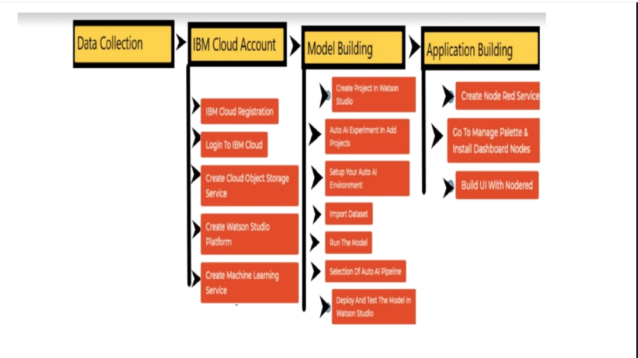

**Result**

After the implimentation of the project the ui predicts the resale value of a vehicle and the Node Red UI provide us simple way to get the result of Auto AI Experiment. The Node Red User Interface can be a web application help the people to be know the approximate predicted resale value.

Here is the Node Red UI which predicts classification

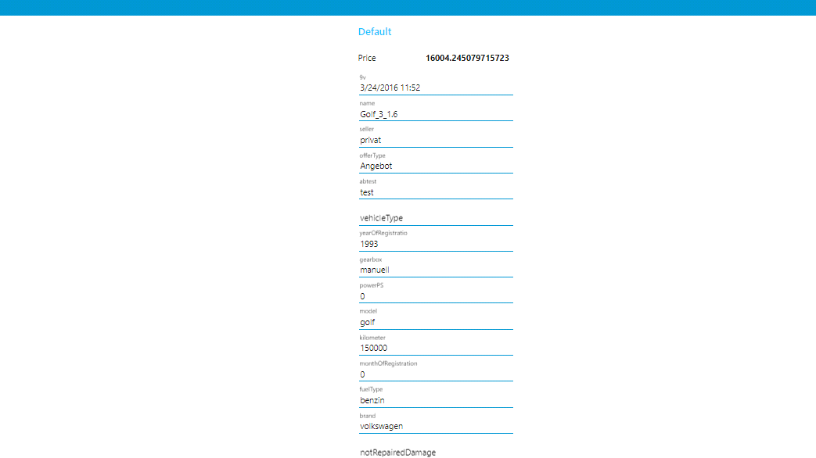

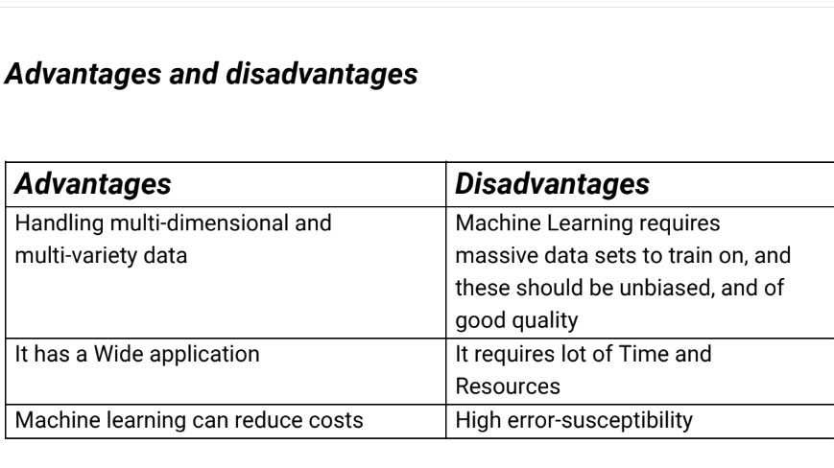

**APPLICATION**

Using The Auto AI Experiment, you can build and deploy a machine learning model with sophisticated training features and no coding. The tool does most of the work for you. In this project , the UI model building can help people a lot.

The Node Red service provide us a better user UI with the help of anyone can deploy machine learning model and get predicted results.

**CONCLUSION**

In this project we have discussed the direct impact of machine learning on economic system. Prediction is inherently difficult: technology modifies its environment and the environment then generates further opportunities and intelligence new constraints for the technology. Ultimately, general purpose will be possible, as a version of it already exists in human brains. However, an extrapolation of existing techniques to re-create general intelligence

artificially appears unlikely in the next 5-10 years. However, what is

immediately plausible, and should therefore be planned for, is a federation of ‘narrow’ and ‘targeted’ machine learning systems that are able to tackle core information processing problems across a world.There is no other approach that offers such potential impact without commensurate scaling of cost.

An opportunity exists to seed growth in machine learning through the creation of high resolution economical data sets and the necessary mechanisms for sharing of data and collaborative investigation to establish both efficacy and safety. the academic AI community, the academic AI community alone will not be able to solve them – it will require leadership from policy makers and

the engagement of citizens.

**FUTURE SCOPE**

AS this the early stages of machine learning their is a lot of scope in future like we shold resolve a lot of disadvantages which we are having currently the we should also be able to use in all forms of society.

**Bibliography**

The whole project uses different services which are listed below

- IBM Cloud

-Watson Studio Auto AI

- Node Red Application

-Cloud Storage Service